AIRM in Balanced4 system on 1/30/06.
Previous close was 20.38 according to P123,

Looking closely at the trading at open, the range was 19.50 to 20.50.

Port Rebalance on Sunday
Accepted Recommendations
No | Accept | Action | Ticker | Name | Shares | Price | Rank | Complete  Statement | Rule
1 |  | SELL | AIRM | Air Methods Corporation | -5,960.0 | 20.4 | 97.6 | Y | Rank

My order to sell AIRM at open with 20.20 limits was executed at 20.50. Good News!

NEXT OPEN was 20.50 according to Scottrade

Looking closely at the actual trading:

Trades ranged from about 19.50 to 20.50 around the open.
Trades below 20.20 (my limit) were less than 1000 shares.
No volume of > 5K shares until about 10:30.

Conclusions:
Volatility at open was about 5% - 19.50 to 20.50 a full point on 20 per share.
Reported opens and close seem to be weighted.
What is the exposure to “whipsaw” at open.
Limit saved me from trades at very low levels

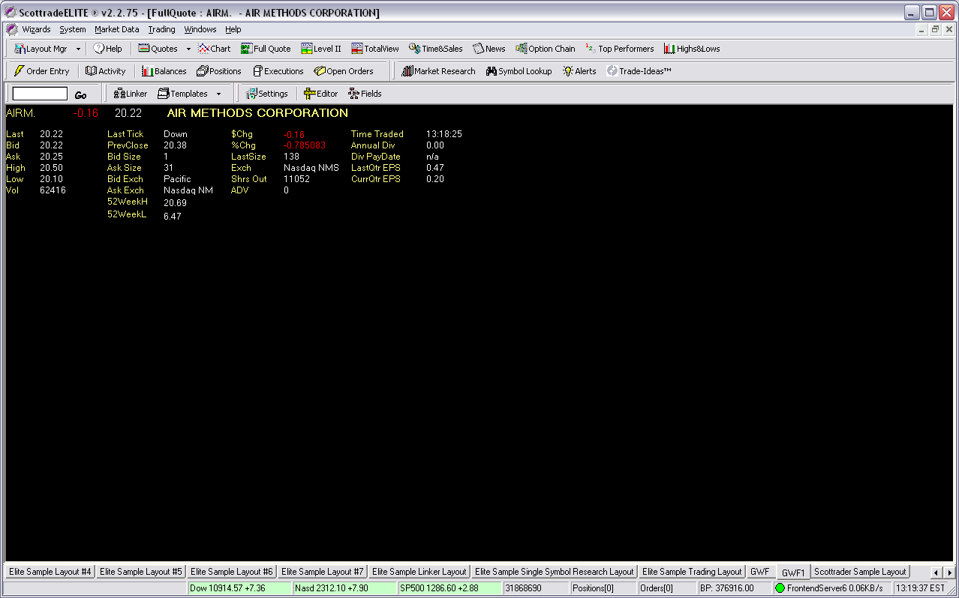

AIRM, 1 minute intervals, about 1:00 PM EST , 1/30/06

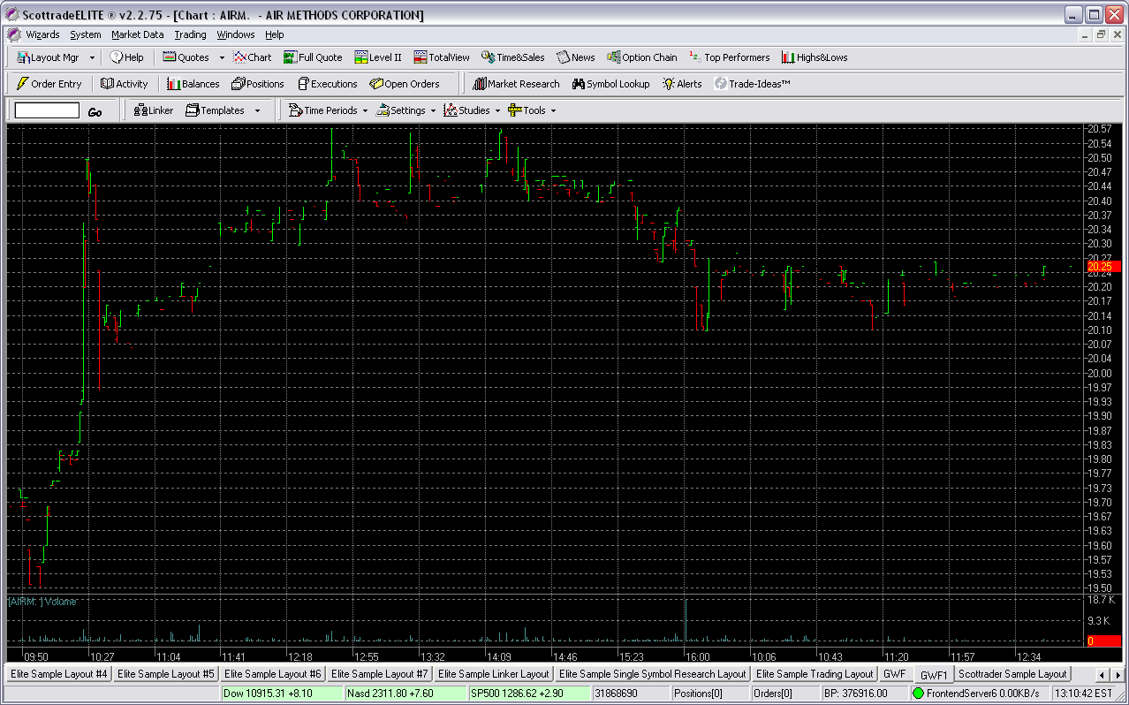

AIRM, 5 minute intervals, for 10 hours @ about 1:00 PM EST , 1/30/06

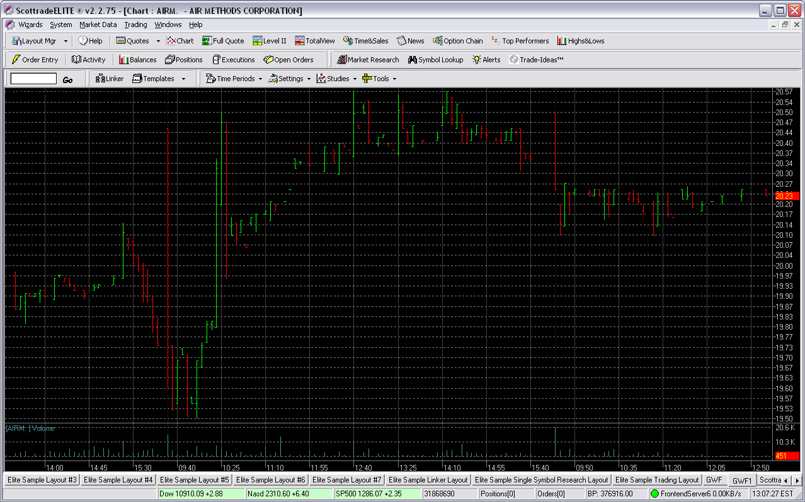

AIRM, 5 minute intervals, for 7 days @ about 1:00 PM EST , 1/30/06

